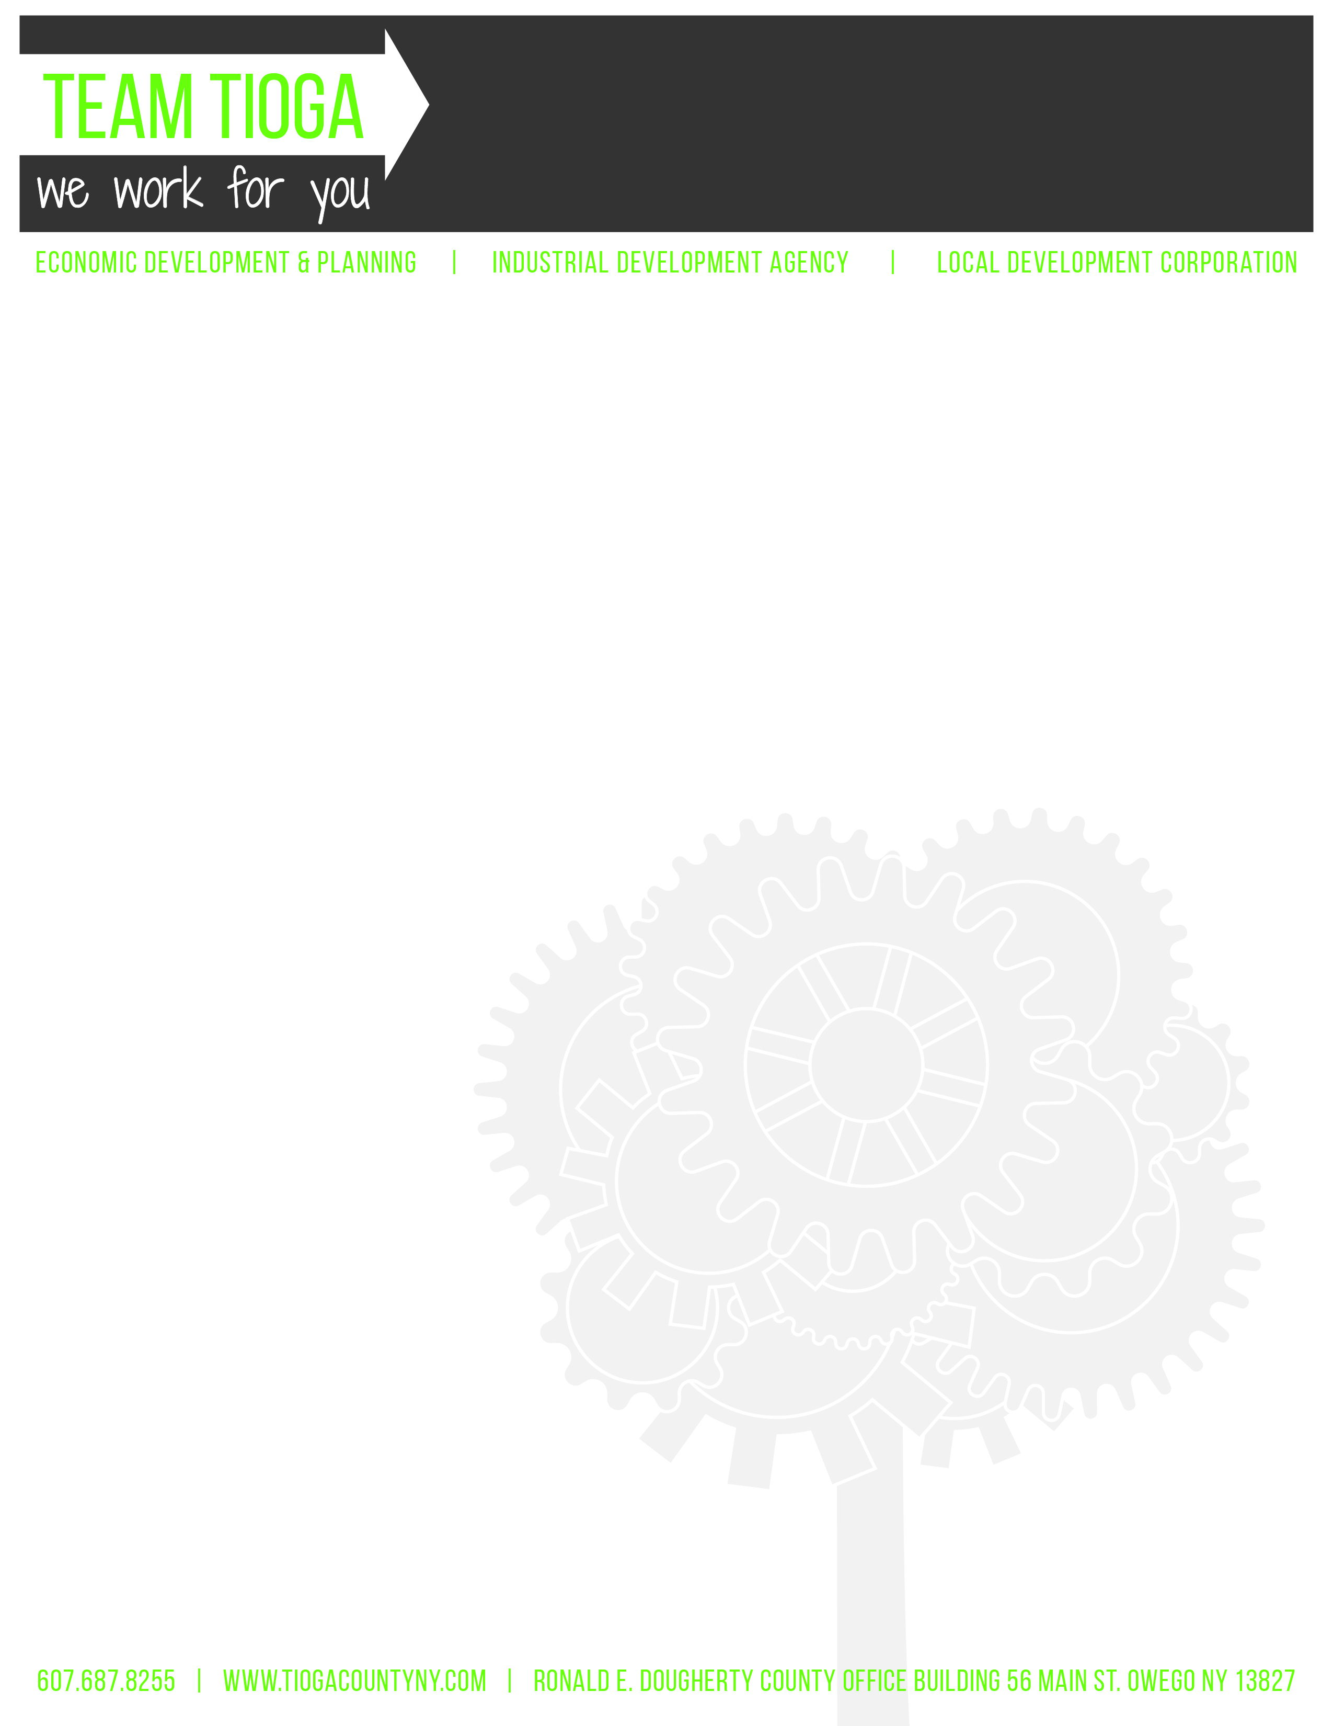

Tioga County Industrial Development Agency
January 6, 2021 – 4 pm
Ronald E Dougherty County Office Building
56 Main Street, Owego, NY 13827

Annual Meeting Minutes via Zoom

Call to Order and Introductions-Chairwoman J. Ceccherelli called the meeting to order at 4:05 pm.

Attendance

IDA Board Members

Roll Call: J. Ceccherelli, K. Gillette, A. Gowan, T. Monell, M. Sauerbrey, E. Knolles, J. Ward

Absent: None

Excused: None

Guests: C. Curtis, M. Griffiths, L. Tinney

New Business

- Monthly Meeting Designation
  - Date- first Wednesday of each month
  - Time- 4:30 p.m.
  - Location- Ronald E. Dougherty County Office Building, 56 Main Street, Owego, ED&P Conference Room, 2nd Floor
Motion to set the regular monthly meetings for the first Wednesday of each month at 4:30 pm in the Ronald E. Dougherty County Office Building, ED&P Conference Room, 2nd Floor, 56 Main St, Owego, NY. (A. Gowan, E. Knolles)
Aye-7 Abstain-0
No-0 Carried
- Media Designation
  - Morning Times
Motion to designate the Morning Times as the official media source for the purposes of publishing all notices and other matters as required by law. (E. Knolles, T. Monell)
Aye-7 Abstain-0
No-0 Carried
- Governance Committee Recommendations
  - Slate of Officers 2021 Proposed List of TCIDA Committee Members
    - Chair- Jenny Ceccherelli
    - Vice Chair- Kevin Gillette
    - Secretary- M. Sauerbrey
    - Treasurer- A. Gowan
  - Committee Appointments
    - Governance- J. Ceccherelli, A. Gowan, E. Knolles
    - Audit- E. Knolles, A. Gowan, J. Ward
    - Railroad- T. Monell, K. Gillette, M. Sauerbrey
    - Finance- J. Ceccherelli, A. Gowan, J. Ward
    - Loan- S. Thomas, R. Kelsey, K. Dougherty, D. Barton. A. Gowan, J. Ward, E. Knolles
    - Public Relations- J. Ceccherelli, L. Tinney, C. Curtis
  - Other Appointments
    - Designee (per Employee Handbook) – L. Tinney
    - Compliance Officer- C. Curtis
    - Contracting Officer- C. Curtis
    - Freedom of Information Officer- C. Curtis
    - Code of Ethics Officer- J. Meagher
    - Internal Controls Officer- J. Nolis
Motion to approve 2021 Slate of Officers, Committee Appointments, and Other Appointments, as recommended by the Governance Committee. (E. Knolles, K. Gillette)
Aye-7 Abstain-0
No-0 Carried

  - Annual Policy Review
    - Mission Statement
    - By-Laws
    - Code of Ethics
    - Assessment of Internal Controls
    - Procurement Policy
    - Property Disposition Policy
    - Whistle Blowers Policy
    - Employee Handbook
    - Governance Committee Charter
    - Procedure Manual
    - TCIDA Sexual Harassment Policy
  - Other Annual Review
    - Compensation and Benefits of Executive Administrator
    - Report on Conflict of Interest Incidents
    - Self-Evaluation of Performance 2020 Governance Committee Self-Evaluation Report
Ms. Curtis noted that the board had previously approved the only two revisions of the year to the by-laws and the procurement policy, and have already previously approved the compensation and benefits of the Executive Administrator, written the report on the conflict of interest incidents, and the self-evaluation of performance for the Governance Committee for 2020.
Motion to approve the annual policy review as recommended by the Governance Committee and to approve the annual compensation and benefits, acceptance of Report on Conflict of Interest Incidents, and Self-evaluation of Performance 2020 Governance Committee Self-Evaluation Report as recommended by the Governance Committee. (M. Sauerbrey, E. Knolles)
Aye-7 Abstain-0
No-0 Carried

- Audit Committee Recommendations
  - Appointments
    - Audit Firm- insero&co
    - Financial Expert- J. Nolis
  - Annual Policy Review
    - Audit Committee Charter TCIDA Audit Committee Charter
    - Self-Evaluation of Performance 2020 Audit Committee Self-Evaluation Report
Motion to approve insero&co as the audit firm and J. Nolis as financial expert as recommended by the audit committee and to accept the reviewed IDA Audit Committee Charter and Self-Evaluation of Performance 2020 Audit Committee Self-Evaluation Report. (A. Gowan, E. Knolles)
Aye-7 Abstain-0
No-0 Carried

- Finance Committee Recommendations
1. Official Depositories
a. Chemung Canal Trust Company
- Community Bank
- Tioga State Bank
- Annual Policy Review
    - Investment Policy
    - Finance Committee Charter
    - Investment Annual Report
    - Self-Evaluation of Performance 2020 Finance Committee Self-Evaluation Report
- Annual Designation of Signors on Bank Accounts
  - J. Ceccherelli, M. Sauerbrey, A. Gowan, C. Curtis
- Annual Certifications
  - Internal Controls Certification
  - Annual Evaluation of Board Performance
  - Fiduciary Responsibilities Certification
  - 2020 TCIDA Operations and Accomplishments
Motion to approve Chemung Canal Trust Company, Community Bank, and Tioga State Bank as official depositories for Tioga County IDA as recommended by the Finance Committee, to accept the reviewed policies and Self-evaluation of Performance 2020 Finance Committee Self-evaluation Report as recommended by the Finance Committee, to approve the designated signors on the accounts as M. Sauerbrey, J. Ceccherelli, A. Gowan, and C. Curtis, to authorize the Internal Controls Certification, Annual Evaluation of Board Performance, and Fiduciary Responsibilities Certification for the year. (K. Gillette, M. Sauerbrey)
Aye-6 Abstain-1 (J. Ward)
No-0 Carried

- Miscellaneous
  - Contact information 2021 TCIDA Board of Directors & Staff
  - Listing of IDA properties – 2020
Ms. Curtis noted that she has sent the board copies of the contact information for the board of directors and staff for 2021, along with a listing of IDA properties, an annual investment report, 2020 accomplishments, and hard copies of two forms to be filled out and returned to Ms. Curtis.

- Adjourned-Ms. Ceccherelli motioned to adjourn the meeting at 4:16 pm.

